Christian Outdoor Leadership by Ashley Denton

Competency

Chapter 1

Recap: Jesus modeled a rhythm of engagement in mission and retreat into the wilderness. His pattern was one of engaging the masses (largely in the cities), and then retreating into the wilderness for rest, renewal, training, and strategizing through silence, solitude, study and prayer. Jesus knew how to be a marathon runner—the pace in which He trained His disciples to “run” was sustainable.

Reflection: Go off to a solitary place walking, climbing, paddling, sitting, whatever. As you retreat with the Lord consider the pattern of your life. Do you regularly get away for rest, renewal, sitting at the feet of your Master to receive training or strategy for being His disciple? What are some ways you can order your life to both engage wholeheartedly in the relationships, work and ministry Jesus calls you to in the city, and regularly retreat for rest to recalibrate your intellect, passion, strength and prayer.

Recap: Retreat is preparation for spiritual conflict and strategizing. Scripture for consideration: Luke 4:1-13, Mark 3:7-12; 6:30-31.

Reflection: If you were honest, would you be able to recognize a spiritual battle going on in your life or in your community? According to Scripture, it was often through times in the desert that Jesus and others were made keenly aware of the ways Satan was seeking to distract, destroy, or discourage. If you knew it would make a significant difference in your life and the health of your community for you to get away regularly to grow a keener ability to recognize the works of Satan, then would you be more motivated to prioritize this rhythm of retreat in your life?

Chapter 2

Give 3 examples of how God used the terrain of the wilderness to cause transformation in people?

Chapter 3

What are some biblical examples of how trials expose unbelief and promote true belief?

Chapter 4

What are some examples of how God builds up people’s ability to trust him through wilderness experiences?

Chapter 5

How has God used the wilderness as a classroom for training his leaders in how to follow him?

Chapter 6

Give a biblical example of each of the ABCDEs. How might you use the ABCDE’s for 1) briefing your trip, 2) debriefing your trip:

Chapter 7

Give an example of how you might want to use an “anticipatory set” to brief your group on a new experience.

Chapter 8

How did Jesus demonstrate that his primary method of growing his Kingdom was through relationships?

Chapter 9

What are some historical examples of how Christians throughout history have used regular retreat for prayer and spiritual growth.

Chapter 10

What are the five essentials of an authentic wilderness experience?

Chapter 11

Write out a teachable moment that you might use in the wilderness. Follow the 5T’s of teachable moments to present your teachable moment.

Chapter 12

Spend some time outside and write out an excellent S+T+IC=K Method version of a teachable moment using the format below:

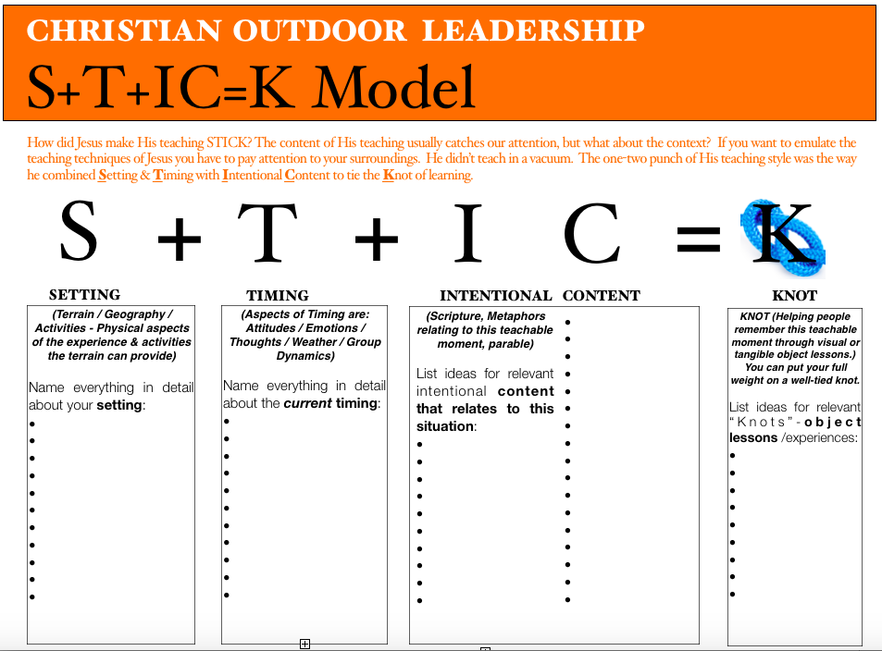

Chapter 13

Explain how humor can create relational breakthroughs in groups:

Chapter 14

Give five biblical examples of how Jesus involved people to get them to participate with him in some way:

Chapter 15

What are the main points of the JEREMIAH Guide preparation plan? Share 3 examples of ways that you may need to grow in any of these areas of preparation:

